CHEMICAL AND MECHANICAL CHARACTERIZATION OF HYALURONIC ACID HYDROGEL CROSS-LINKED WITH POLYETHYLEN GLYCOL AND ITS USE IN DERMATOLOGY.

Nicola Zerbinati¹, Cristina Esposito², Giovanna Cipolla², Alberto Calligaro³, Damiano Monticelli⁴, Virginia Martina⁵, Masa Golubovic⁶, Iva Binic, ⁷. Julia Sigova⁸, Anna. L. Gallo⁵, Edoardo D’Este², Mohammad Jafferany⁹, Marina Pratosoni¹, Michael Tirant¹⁰, Nguyen Van Thuong¹⁰, Fabiola Sangalli², Raffaele Rauso¹¹, Torello Lotti¹²

Nicola | Zerbinati | nicola.zerbinati@uninsubria.it
Cristina | Esposito | cesposito@centro-medico.it
Giovanna | Cipolla | giovannacipolla13@gmail.com
Alberto | Calligaro | alberto.calligaro@unipv.it
Damiano | Monticelli | damiano.monticelli@uninsubria.it
Virginia | Martina | v.martina@matexlab.com
Anna | Gallo | a.gallo@matexlab.com
Edoardo | D'Este | edeste@centro-medico.it
Marina | Protasoni | marina.protasoni@uninsubria.it
Fabiola | Sangalli | fabi-92@live.it
Raffaele | Rauso | dr.raffaele.rauso@gmail.com
Torello | Lotti | professor@torellolotti.it
Masa | Golubovic | masabinic@gmail.com
Iva | Binic | ivabinic@gmal.com

This article has been accepted for publication and undergone full peer review but has not been through the copyediting, typesetting, pagination and proofreading process which may lead to differences between this version and the Version of Record. Please cite this article as doi: 10.1111/dth.13747

Julia | Sigova | sigovay@gmail.com
Michael | Tirant | drmichael@psoriasis.com.au
Nguyen Van | Thuong

¹ University of Insubria, Department of Medicine and Surgery, Varese, Italy.

² Centro Medico Polispecialistico, Pavia, Italy.

³ University of Pavia, Department of Public Health, Experimental and Forensic Medicine

⁴ University of Insubria, Department of Science and High Technology, Como, Italy

⁵ Matex Lab S.p.A., Brindisi, Italy

⁶ Department of Dermatology, Clinical Center University of Nis, Serbia

⁷ Department of Psychiatry, Clinical Center, University of Nis, Serbia

⁸ Department of Neonatology, Faculty of Continued Medical Education of Pirogov Russian National Research Medical University, Moscow, Russia
⁹Central Michigan University, Saginaw, Michigan USA

¹⁰ Hanoi Medical University, Department of Dermatology, Hanoi, Vietnam

¹¹ Maxillofacial Surgery Unit, University of Campania “Luigi Vanvitelli”, Naples, Italy

¹² Department of Dermatology, University of Rome G. Marconi, Rome, Italy

Corresponding Author

Mohammad Jafferany, MD

ABSTRACT

Introduction:

Hydrogels based on hyaluronic acid are used to restore volume, hydration and skin tone, as well as to correct scars, asymmetries or defects of the soft tissue.
Hyaluronic acid is often chemically crosslinked with different crosslinking agents in order to improve its mechanical and biological properties.
Here we focused on defining the chemical and mechanical characterization of a new hydrogel with specific characteristics: hyaluronic acid polyethylene glycol (PEG)-crosslinked with a high concentration of hyaluronic acid (28 mg / ml), manufactured by MatexLab Spa, via Carlo Urbani 2, ang Via Enrico Fermi, Brindisi, Italy.
Methods:

We made a quantitative and qualitative analysis of the content of sodium hyaluronate in the hydrogel after polymerization and sterilization processes and also evaluated histologically the bio integration of these hydrogels in the cutaneous soft tissues.
Results:

The results suggest that hyaluronic acid hydrogel PEG-crosslinked have great bio integration, great chemical and mechanical properties, compared with other products available on the market, that are cross-linked with different cross-linking agents.
Conclusion:

The non-toxicity and non-immunogenicity of PEG guarantee the lack of allergic and immunological reactions. The PEG-crosslinking technology guarantees a high duration time of the implanted hydrogel because of more resistant physiological degradation.

KEYWORDS:

Chemical characterization, Cross-linked, Dermal filler, Hyaluronic acid, Mechanical characterization, Polyethylene glycol

INTRODUCTION

Hyaluronic acid is an heteropolymer characterized by sequences of glucuronic acid and n- acetylglucosamine bonded by a β-1-3 glycosidic bond. Each unit is bound thanks to a β-1-4 glicosidic bond (1).
Up to 25,000 bound disaccharides units may be found in mammal tissues, reaching a molecular weight of 5x10 ⁵ – 5x10 ⁶ Da (2).
Hyaluronic acid (HA) is a glycosaminoglycan with important biological functions thanks to its peculiar structure and its ability to attract a great amount of water. HA makes the extra cellular matrix hydrated, stable and open so that molecules like other glycosaminoglycans (GAGs), collagen and elastin can build a kind of network called “scaffold” (3).
HA is synthetized by three hyaluronic acid synthases (HAS 1,2,3) [11; 12; 13] on the cellular membrane and it is extruded from the cell when assembled. 15 g of Ha are typically found in an adult human body, 7 g of which can be found in the dermis (1, 4-9).
HA is degraded (approximately 30% of the total amount per day), by different hyaluronidases, by UV radiation and by free radicals produced during inflammatory processes (10).
Formulations based on hyaluronic acid are nowadays used in aesthetic medicine, plastic surgery and dermatology as a filler to correct soft tissue deficits or in the scar management (11, 35, 36).
Although hyaluronic acid without any further modification is sometimes used, hydrogels including crosslinked HA found by far more widespread application in these fields. A crosslinked hydrogel is a formulation in which HA chains have been bound (crosslinked) by means of a different molecule called crosslinker (CL). The obtained structure features both covalent bonds (which are formed by chemical reaction between HA and CL), and physical cross-links, intended as electrostatic

interactions, which are formed between the various entanglements of the chains, hydrogen bonds and/or van der Waals interactions.
The hydrogel properties are dictated by the number of crosslinks, obtained by the reaction of HA and CL present. In the world of fillers, the preferred reaction between HA and CL leads to the formation of covalent bonds in order to increase the hydrogel resistance to the attacks of hyaluronidase (31, 34), and, as a result, to increase the post-implant duration in the dermis. Usually, the formation of ether bonds C-O-C is sought, as they are stable in physiological conditions in the dermis. A linear molecule with epoxide functionalities at both ends is usually employed as a crosslinker: the reaction consists in the deprotonation of one hydroxyl group on HA which act as a nucleophile for the opening of the epoxide ring leading to the formation of the C-O-C bond.
Polyethylene glycol diglycidyl ether (PEGDE) is a difunctional, highly water-soluble crosslinker for amine-, hydroxyl-, and carboxyl-functional polymers.
Polyethylene glycol (PEG) is a highly investigated polymer for the covalent modification of biological macromolecules and surfaces for many pharmaceutical and biotechnical applications (12). PEG is a linear or branched polyether with a wide range of applications in the biomedical field. PEG is a non-toxic, non-immunogenic polymer that is often referred to as a “stealthy molecule” because it is not recognized by biological molecules like proteins. PEG has been widely used for its ability to form stealth compounds upon conjugation with other polymers or protein because of its ability to escape the mononuclear phagocyte system in the bloodstream (13).
PEG is generally considered to have low toxicity by all routes of administration (14): its metabolism was reviewed by Webster et al. (15). The molecular weight of PEGD is not known. In general, PEG

is not considered biodegradable except for low molecular weight species (<400 Da) that may be degraded by alcohol dehydrogenase in vivo (12, 13, 15-28).
Its application as a crosslinker for HA hydrogels stems from the combination of its low toxicity and the good rheological properties of PEG crosslinked hydrogels (33).
The aim of this study was to evaluate the chemical, viscoelastic and biological properties of a recently introduced hydrogel based on PEG-crosslinked hyaluronic acid with a high concentration of HA (28 mg/ml), commercialized as Neauvia Intense (MatexLab, SA). Firstly, the fundamental chemical features and the viscoelastic properties of the hydrogel will be dealt with. In the second part, histological studies will be presented to establish the compatibility, behaviour and effectiveness of the novel hydrogel.

METHODS

HA qualitative identification

The presence of HA in the final product, i.e. after sterilization of the hydrogel, was assessed by 13C CP-MAS Nuclear Magnetic Resonance (NMR). The spectrum of the sample (crosslinked HA hydrogel, HA 28 mg/ml, lot HA2161101) was registered after oven drying. The spectrum of pure hyaluronic acid was registered for comparison purposes.
HA quantitative determination

For the quantitative analysis of the content of HA it was created a specific protocol optimized from the “EP01/2005: 1472C” method (29, 30, 32).
In brief, hyaluronic acid is reacted with carbazole after digestion in sulfuric acid in the presence of tetraborate leading to the formation of a product with maximum absorbance at 530 nm. The

percentage content of sodium hyaluronate was then calculated by a calibration curve obtained by measuring standard solutions of the substrate.
Detection of residual PEGDE in the hydrogel

The presence of residual unreacted crosslinker (PEGDE) in the hydrogel was investigated by mass spectrometry at the laboratory CNR IPCB of Catania (Italy). A Thermo Exactive Plus Orbitrap was used for the measurements which were performed on the ethanolic extract of the sample.
Viscoelastic properties

The evaluation of the mechanical properties of the PEGylated HA hydrogel was performed by a Kinexus Instrument Rheometer at a temperature of 25 ° C. A 20 mm diameter plate is used in combination with a Peltier bottom plate. Each test was performed three times to validate reproducibility.
Before measurement, the instrument calibration was verified using a certified standard oil. Then the hydrogel can be pressed through a needle to deposit the hydrogel on the plate. . The excess of the product was removed by a spatula. After establishing the distance, the sample temperature was set to 25°C with an accuracy of 0.5°C.
Cohesive strength measurements were performed by setting the rheometer to a Normal Force mode: the upper plate is put in contact with 2.5 g of gel and is lowered toward the bottom plate, thus compressing the gel. The course is stopped when 60% of compression is reached. The resulting normal force is measured during the experiment, from 0 to 60% compression rate. Gel parameters,
i.e. hardness and cohesivity, were determined from the resultant force-time plot. The maximum force represents the hardness of the hydrogel formulation, while cohesivity is defined as the work required to deform the hydrogel in the down movement of the probe.

Oscillation tests included variable amplitude and variable frequency tests were performed. In particular, Amplitude strain sweep test at a frequency of 1 Hz and amplitude strain 0.01-2000% was assayed to determine the plasticity, also defined critical strain, and the linear viscoelastic region (LVER). Subsequent frequency sweep test was performed at a constant strain within the LVER (1%) and frequency 0.1-10Hz.
Histological studies

The goal of this study was also to evaluate the bio-integration of the HA dermal filler in the soft tissue.
Five volunteers received an injection of 1 ml of PEG-crosslinked, HA dermal filler (28 mg/mL) into the hypodermis and 8 month later skin biopsies were carried out. The five volunteers for the histological analysis were chosen among around 500 patients, who were treated at the Centro Medico Polispecialistico in Pavia between August and December 2017. Volunteers needed a surgery approximately in the area of the HA implant a few months after injection as needed to obtain histological samples.
The bioptical samples were fixed in a 4% formaldehyde solution for 24h and then dehydrated, embedded in paraffin and sectioned in 7 μm sections.
Sections were stained either with Hematoxylin and Eosin or with a 1% Alcian blue solution in 3% acetic acid for 30 minutes. Every section was than observed with a Carl Zeiss Axioplan microscope equipped with a High Definition ccd 5-megapixel camera Nikon-Fi2 for recording images.
The latter study was conducted in accordance with International Standards Organization 14155:2011: Clinical investigation of medical devices for human subject- Good clinical practice (GCP), the principles of the 1964 Helsinki Declaration and its later amendments, and the applicable sections of

the national medical device law. Informed consent was obtained from all individual participants included in the study.”

RESULTS

The results of the chemical analyses will be presented first, followed by the characterization of the viscoelastic properties; histological evidences will be subsequently introduced.
Chemical analyses aimed at assessing the presence of intact hyaluronic acid in the hydrogel, i.e. that the crosslinking and sterilization phases had no effect on the HA structure, and the absence of detectable amounts of residual PEGDE, which could pose potential risks for human health.
Figure 1 depicts the CP/MAS NMR spectra of pure hyaluronic acid (blue) and the dried hydrogel (black, lot HA2161101). The spectra clearly show that the signals of hyaluronic acid are retained in the spectrum of the hydrogel sample with the small differences due to the presence of PEG.

The concentration of sodium hyaluronate was quantified by the modified carbazole reaction (see Materials and Methods).
The percentage of crosslinked sodium hyaluronate in the 28 mg / ml hydrogel (lot HA2161101, Matex Lab S.p.a.) calculated according to the internal method is reported in Table 1.

The obtained result (2.77±0.29%) is not statistically different from the expected one based on the product formulation, i.e. 2.8wt%.

Finally, the absence of residual PEGDE in the hydrogel was assessed by high resolution mass spectrometry on a sample of the hydrogel. As a result, no mass peak due to the epoxy rings could be found: although the quantification of the residual PEGDE is not possible, the very high sensitivity of the analytical instrumentation ensures that the residual PEGDE concentration is lower than a few parts per billion.
Rheological data obtained by both the frequency sweep test and the shear test are reported in figures 2 and 3 and the data in tables 2 and 3. Cohesivity is reported in figure 4.
As an additional data, the mean viscosity value for a stress value of 1 s⁻¹ was 253 Pa s, with a 10% of relative standard deviation. However, plasticity is defined as the critical deformation of a solid-like material when is subjected to strain hardening. The increase of the material plasticity is due to its high capability to deform. The plasticity related to hydrogel based on PEG-crosslinked hyaluronic acid with a high concentration of HA (28 mg/ml) Lot. HA2161105 was determined as 1782±3 (mean ± standard deviation, three replicates).
Rheological data clearly show that the elastic behavior is dominant in the investigated hydrogel and the elastic properties are retained over a large range of applied stress (see the discussion section for an interpretation of these data).
The cohesivity of the hydrogel was also measured on two lots of the 28 mg/ml HA PEG-crosslinked hydrogel. The results were 1.79±0.02 N*s (mean values ± 1 standard deviation, 3 replicate measurements).
Hardness of the hydrogel is defined as a force necessary to achieve maximum compression. The results were 0.69±0.05 N.

The results of the histological investigations are reported in the following figures (Figure 5-7). Main evidences are presented here, whereas their relevance is discussed in the following section. Histological sections were stained with Hematoxilkin and Eosin for general survey of tissues, and with Alcian blue, a specifica stain for the demonstration of glycosaminoglycans (as hyaluronic acid) in the sections.

DISCUSSION

The analysis of the chemical data shows that the initial 28mg/ml hyaluronic acid concentration does not undergo variations during the crosslinking process with polyethylene glycol and the sterilization of the same hydrogel performed in an autoclave in order to obtain the sterility of the product, a fundamental requirement for its injectability.
Even the analyses conducted with CP-MAS NMR (Cross Polarization Magic Angle Spinning Nuclear Magnetic Resonance) did not show alterations in the structure of sodium hyaluronate. Moreover, chemical analyses showed that no residual PEGDE is present in the hydrogel, a fundamental feature to avoid health risk. In details, the concentration of residual PEGDE was estimated to be lower than 10 ng/mL: although no detailed risk assessment was conducted on residual PEGDE, evaluations on residual BDDE in HA hydrogels evidenced that a residual concentration of 2 µg/mL leads to a minimal cancer risk associated to BDDE exposure (U.S. Food and Drug Administration (FDA), Cancer Risk Assessment, Advisory Panel Briefing Information, PMA P020023).
The chemical structure of the polyethylene glycol appears to make the final polymeric structure of the hydrogel less rigid than other crosslinking chemical agents with comparable crosslinking ratios (32).

It has also been reported that the hydrogel was itself more resistant to physiological degradation maintaining biocompatibility and HA biological activity (27).
The rheological characterization of the hydrogels used as dermal fillers is of the utmost importance to define their behavior once injected into the skin. A purely elastic solids deform up to a certain point under shear stress and recover when the stress is removed. A purely viscous fluid instead undergoes a progressive and irreversible strain under shear stress: when the stress is removed, the material remains deformed. Although different effects are targeted by aesthetic treatments (pure volume, contouring, lifting, etc.), a dermal filler should always show an elastic behavior to recover its shape after deformation due to skin movements and avoid flowing away from the injection site. The behavior of a gel under stress, is described by the complex module (G *) that can be divided into two components:
- G ': the elastic module, the contribution of the elastic (solid-like) behavior

- G ": the viscous module, the contribution of viscous (liquid-like) behavior

The evaluation of the data (see Figures 2 and 3 and Tables 2 and 3) shows a predominance of the elastic component compared to the viscous component, giving the hydrogel a solid like behaviour, while maintaining excellent characteristics of plasticity and extrusibility.
In particular, under the stress due to facial movements, high G′ gels will remain more stable in volume, due to their low deformability, therefore the hydrogel is associated with a lower migration in the skin, allowing much more natural and stable results.
The analysis of the rheological data shows how the HA (28 mg/mL) PEG-crosslinked is associated with a high cohesivity, retaining at the same time the correct viscoelasticity properties. Hydrogels

with high cohesivity allow to obtain a better resistance to mechanical degradation and prevent gel migration, showing as a consequence, a better duration in the skin and maintaining the initial shape of gel deposit. These features are possible thanks to the PEG-crosslinking technology.
Another important parameter to consider is the plasticity, the propensity of a material to undergo permanent deformation under load. Hydrogel with low plasticity have more adaptability, while filler with high plasticity are less malleable and are associated with more vertical vector projection.
The dermo-histological analysis has demonstrated, an optimal distribution and integration in the connective tissue of the PEG-crosslinked HA hydrogels. The injected filler appears harmoniously integrated with the structures within the connective tissue, such as collagen fibres, blood and lymphatic vessels, glands and nerves. Furthermore, if we consider that our observations in these subjects were made eight months after the filler injection, it means that this material was for the most part retained in hypodermic tissue, with very low dissolution and very limited diffusion out of the injection site. Moreover, the dermo-histological analysis has demonstrated the absence of any adverse reaction, inflammatory cells surrounding the implant or closely associated with it have never been found (26).
The major weakness of this study is the lack of a comparison with data from similar studies obtained by other products on the pharmaceutical market.
One other limit of the study is the absence of an in vivo study, using different products to evaluate their potential and defects.
On the other hand, the histological evaluation allows to really understand how the hydrogels interact with the derma and the different structures in it. The study is completed with laboratory analyses that

inquire precisely physical and mechanical proprieties of the filler, making clear the final proprieties of the product starting from the elements that compose itself.

CONCLUSIONS

The ideal properties that a filler should have to ensure optimal patient outcome include several different features: the ability to restore volume, the ease of injection, the hypo allergenicity, the malleability, the reversibility of treatment, the duration of the injected product, the security, the natural appearance, the minimal discomfort of the patient and the minimum patient inactivity time. In our study, there are clinical evidence of a low discomfort for the patience during the injection and in post-treatment thanks to the excellent characteristics of plasticity and extricability of the PEG crosslinked hydrogel. The non-toxicity and non-immunogenicity of the PEG guarantee the lack of side allergic and immunological effect.
At the same time a high duration time of the hydrogel is guarantee by the new crosslinking method and the PEG structure; it results in a more solid and more resistant to physiological degradation product. We had evidence of a duration of more than eight months in the hypodermic tissue, although in general, it would not be expected that the gel will stay for periods over several months.
This new class of hydrogel, thanks to its peculiar chemical and mechanical characteristics, marked biocompatibility and bio integration, becomes eligible for use as real scaffolds in the reconstructive treatment of dermal soft tissue defects.

ACKNOWLWDGMENTS

Funding:

The research was supported by Matex Lax spa. No funding or sponsorship was received for the publication of this article. The article processing charges were funded by the authors.
Authorship:

All authors had full access to all of the data in this study and take complete responsibility for the integrity of the data and accuracy of the data analysis.
The authors approved the final version to be published after critically revising the manuscript for important intellectual content. All named authors meet the International Committee of Medical Journal Editors (ICMJE) criteria for authorship for this article, take responsibility for the integrity of the work as a whole, and have given final approval to the version to be published.
Disclosures:

The authors declare that they have no conflict of interest.

Compliance with ethic guidelines:

All procedures performed in studies involving human participants were in accordance with the ethical standards of the institutional and/or national research committee and with the 1964 Helsinki declaration and its later amendments or comparable ethical standards. Informed consent was obtained from all individual participants included in the study.
Data availability:

All data generated or analysed during this study are included in this published article.

REFERENCES

- Siliprandi, N. & Tettamanti, G. Biochimica medica strutturale metabolica e funzionale. (Piccin- Nuova Libraria, 2011).
- Fraser JR, Laurent TC, Laurent UB. Hyaluronan: its nature, distribution, functions and turnover.

J Intern Med 1997; 242(1):27-33.

- Laurent TC, Fraser JR. Hyaluronan. FASEB J 1992; 6(7):2397-404.

- Viola M, Vigetti D, Karousou E, D'Angelo ML, Caon I, Moretto P, De Luca G, Passi A. Biology and biotechnology of hyaluronan. Glycoconj J 2015; 32(3-4):93-103.
- Lee JY, Spicer AP. Hyaluronan: a multifunctional, megaDalton, stealth molecule. Curr Opin Cell Biol 2000; 12(5):581-6.
- Vigetti D, Clerici M, Deleonibus S, et al. Hyaluronan synthesis is inhibited by adenosine monophosphate-activated protein kinase through the regulation of HAS2 activity in human aortic smooth muscle cells. J Biol Chem 2011; 286(10):7917-24.
- Vigetti D, Deleonibus S, Moretto P, et al. Role of UDP-N-acetylglucosamine (GlcNAc) and O- GlcNAcylation of hyaluronan synthase 2 in the control of chondroitin sulfate and hyaluronan synthesis. J Biol Chem 2012; 287(42):35544-55.
- Karousou E, Kamiryo M, Skandalis SS, et al. The activity of hyaluronan synthase 2 is regulated by dimerization and ubiquitination. J Biol Chem 2010; 285(31):23647-54.
- Deen AJ, Rilla K, Oikari S, at al. Rab10-mediated endocytosis of the hyaluronan synthase HAS3 regulates hyaluronan synthesis and cell adhesion to collagen. J Biol Chem 2014; 289(12):8375- 89.

- Soltés L, Mendichi R, Kogan G, Schiller J, Stankovska M, Arnhold J. Degradative action of reactive oxygen species on hyaluronan. Biomacromolecules 2006; 7(3):659-68.
- Brandt FS, Cazzaniga A. Hyaluronic acid gel fillers in the management of facial aging. Clin Interv Aging 2008; 3(1):153-9.
- Roberts MJ, Bentley MD, Harris JM. Chemistry for peptide and protein PEGylation. Adv Drug Deliv Rev 2002; 54(4):459-76.
- Lam J, Truong NF, Segura T. Design of cell-matrix interactions in hyaluronic acid hydrogel scaffolds. Acta Biomater 2014; 10(4):1571-1580.
- Webster, R. et al. PEG and PEG conjugates toxicity: towards an understanding of the toxicity of PEG and its relevance to PEGylated biologicals. in PEGylated Protein Drugs: Basic Science and Clinical Applications (ed. Veronese, F. M.) 127–146 (Birkhäuser Basel, 2009). doi:10.1007/978-3-7643-8679-5_8
- Webster R, Didier E, Harris P, Siegel N, Stadler J, Tilbury L, Smith D. PEGylated proteins: evaluation of their safety in the absence of definitive metabolism studies. Drug Metab Dispos 2007; 35(1):9-16.
- Fakhari A, Berkland C. Applications and emerging trends of hyaluronic acid in tissue engineering, as a dermal filler and in osteoarthritis treatment. Acta Biomater 2013; 9(7):7081- 92.
- Varma DM, Gold GT, Taub PJ, Nicoll SB. Injectable carboxymethylcellulose hydrogels for soft tissue filler applications. Acta Biomater 2014; 10(12):4996-5004.
- Donofrio L, Weinkle S. The third dimension in facial rejuvenation: a review. J Cosmet Dermatol 2006; 5(4):277-83.

- Wollina, U. & Goldman, A. Hyaluronic Acid Dermal Fillers: Safety and Efficacy for the Treatment of Wrinkles, Aging Skin, Body Sculpturing and Medical Conditions. Clinical Medicine Reviews in Therapeutics 3, 107–121 (2011).
- Kablik J, Monheit GD, Yu L, Chang G, Gershkovich J. Comparative physical properties of hyaluronic acid dermal fillers. Dermatol Surg 2009; 35 Suppl 1:302-12.
- Edsman K, Nord LI, Ohrlund A, Lärkner H, Kenne AH. Gel properties of hyaluronic acid dermal fillers. Dermatol Surg 2012; 38(7 Pt 2):1170-9.
- Tripodo G, Trapani A, Rosato A, Di Franco C, Tamma R, Trapani G, Ribatti D, Mandracchia

D. Hydrogels for biomedical applications from glycol chitosan and PEG diglycidyl ether exhibit pro-angiogenic and antibacterial activity. Carbohydr Polym 2018; 198:124-130.
- Working, P. K., Newman, M. S., Johnson, J. & Cornacoff, J. B. Safety of Poly(ethylene glycol) and Poly(ethylene glycol) Derivatives. in Poly(ethylene glycol) 680, 45–57 (American Chemical Society, 1997).
- Baumann A, Tuerck D, Prabhu S, Dickmann L, Sims J. Pharmacokinetics, metabolism and distribution of PEGs and PEGylated proteins: quo vadis?. Drug Discov Today 2014; 19(10):1623-31.
- Fruijtier-Pölloth C. Safety assessment on polyethylene glycols (PEGs) and their derivatives as used in cosmetic products. Toxicology 2005; 214(1-2):1-38.
- Zerbinati N, D'Este E, Farina A, Rauso R, Cherubino M, Calligaro A. Morphological evidences following pegylated filler treatment in human skin. J Biol Regul Homeost Agents 2017; 31(2 Suppl. 2):79-85.

- Zerbinati N, Lotti T, Monticelli D, et al. In Vitro Evaluation of the Biosafety of Hyaluronic Acid PEG Cross-Linked with Micromolecules of Calcium Hydroxyapatite in Low Concentration. Open Access Maced J Med Sci 2018; 6(1):15-19.
- Zerbinati N, Rauso R, Gonzalez P, et al. In vitro evaluation of collagen production on human fibroblasts treated with hyaluronic acid peg cross-linked with micromolecules of calcium hydroxyapatite in low concentration. J Biol Regul Homeost Agents 2017; 31(2 Suppl. 2):87-90.
- Dong, Q. et al. Rapid determination of hyaluronic acid concentration in fermentation broth with near-infrared spectroscopy. J. Innov. Opt. Health Sci. 07, 1450012 (2013).
- Bitter T, Muir HM. A modified uronic acid carbazole reaction. Anal Biochem 1962; 4:330-4.

- Zerbinati N, Mocchi R, Galadari H, et al. In Vitro Evaluation of the Biological Availability of Hyaluronic Acid Polyethylene Glycols-Cross-Linked Hydrogels to Bovine Testes Hyaluronidase. Biomed Res Int 2019; 2019:3196723.
- Monticelli D, Martina V, Mocchi R, Rauso R, Zerbinati U, Cipolla G, Zerbinati N. Chemical Characterization of Hydrogels Crosslinked with Polyethylene Glycol for Soft Tissue Augmentation. Open Access Maced J Med Sci 2019; 7(7):1077-1081.
- Martina V, Gallo A, Tarantino E, et al. Viscoelastic properties and thermodynamic balance improvement of a hyaluronic acid hydrogel enriched with proline and glycyne. J Biol Regul Homeost Agents 2019; 33(6).
- Zerbinati N, Lotti T, Monticelli D, et al. In Vitro Evaluation of the Sensitivity of a Hyaluronic Acid PEG Cross-Linked to Bovine Testes Hyaluronidase. Open Access Maced J Med Sci 2018; 6(1):20-24.

- Zerbinati N, Haddad RG, Bader A, et al. A new hyaluronic acid polymer in the augmentation and restoration of labia majora. J Biol Regul Homeost Agents 2017; 31(2 Suppl. 2):153-161.
- Zerbinati N, Rauso R, Protasoni M, et al. Pegylated hyaluronic acid filler enriched with calcium hydroxyapatite treatment of human skin: collagen renewal demonstrated through morphometric computerized analysis. J Biol Regul Homeost Agents 2019; 33(6):1967-1971.

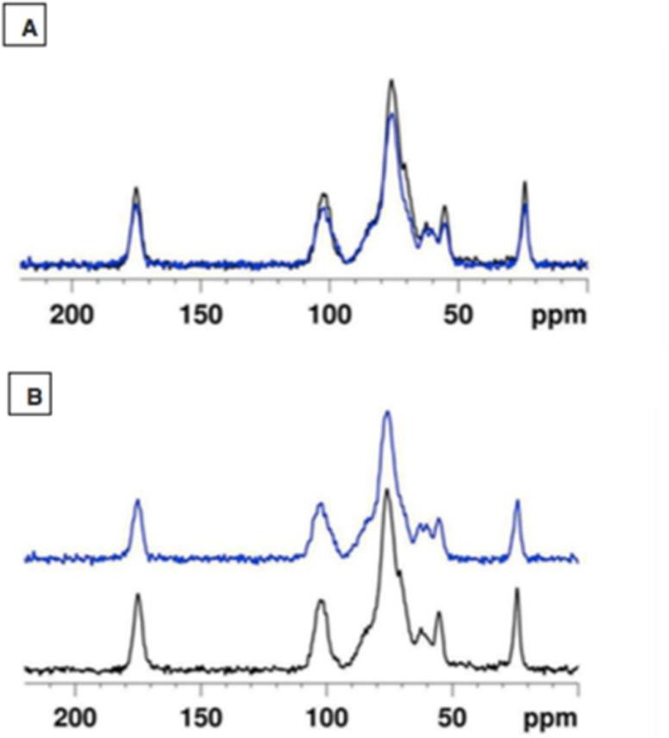

Fig. 1: CP/MAS spectra of pure hyaluronic acid (blue) and the dried hydrogel (black).
Accepted Article

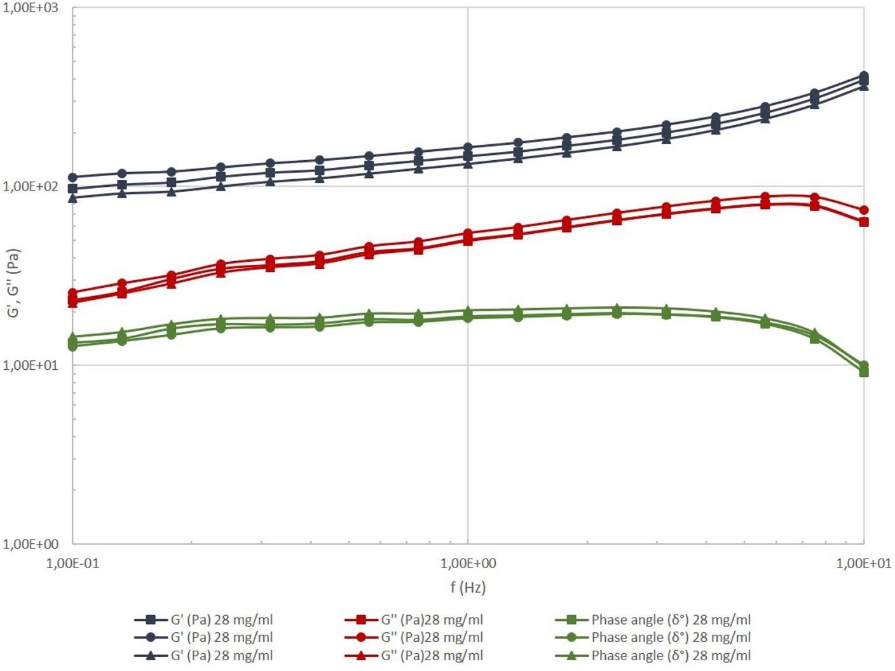
Figure 2: Curves obtained from the Frequency sweep test. 0.1-10Hz, 1%, 25 ° C
Accepted Article
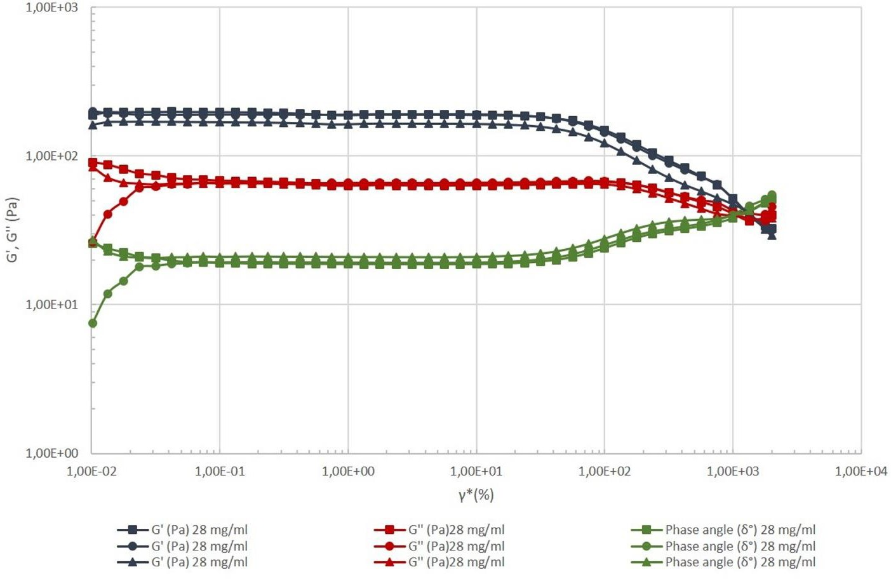
Figure 3: Evolution of viscoelastic parameters depending on the applied stress, 0.01-2000%, 1Hz, 25 ° C.

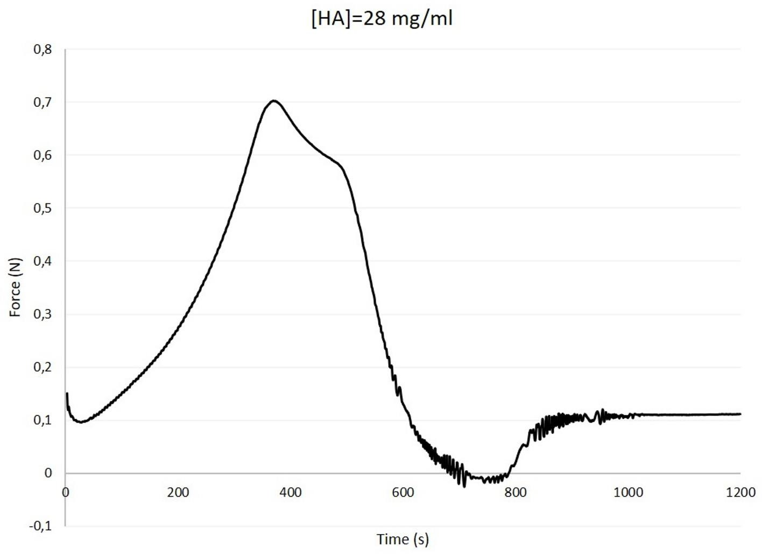

Figure 4: Typical force versus time plot of a compression cycle.
Accepted Article

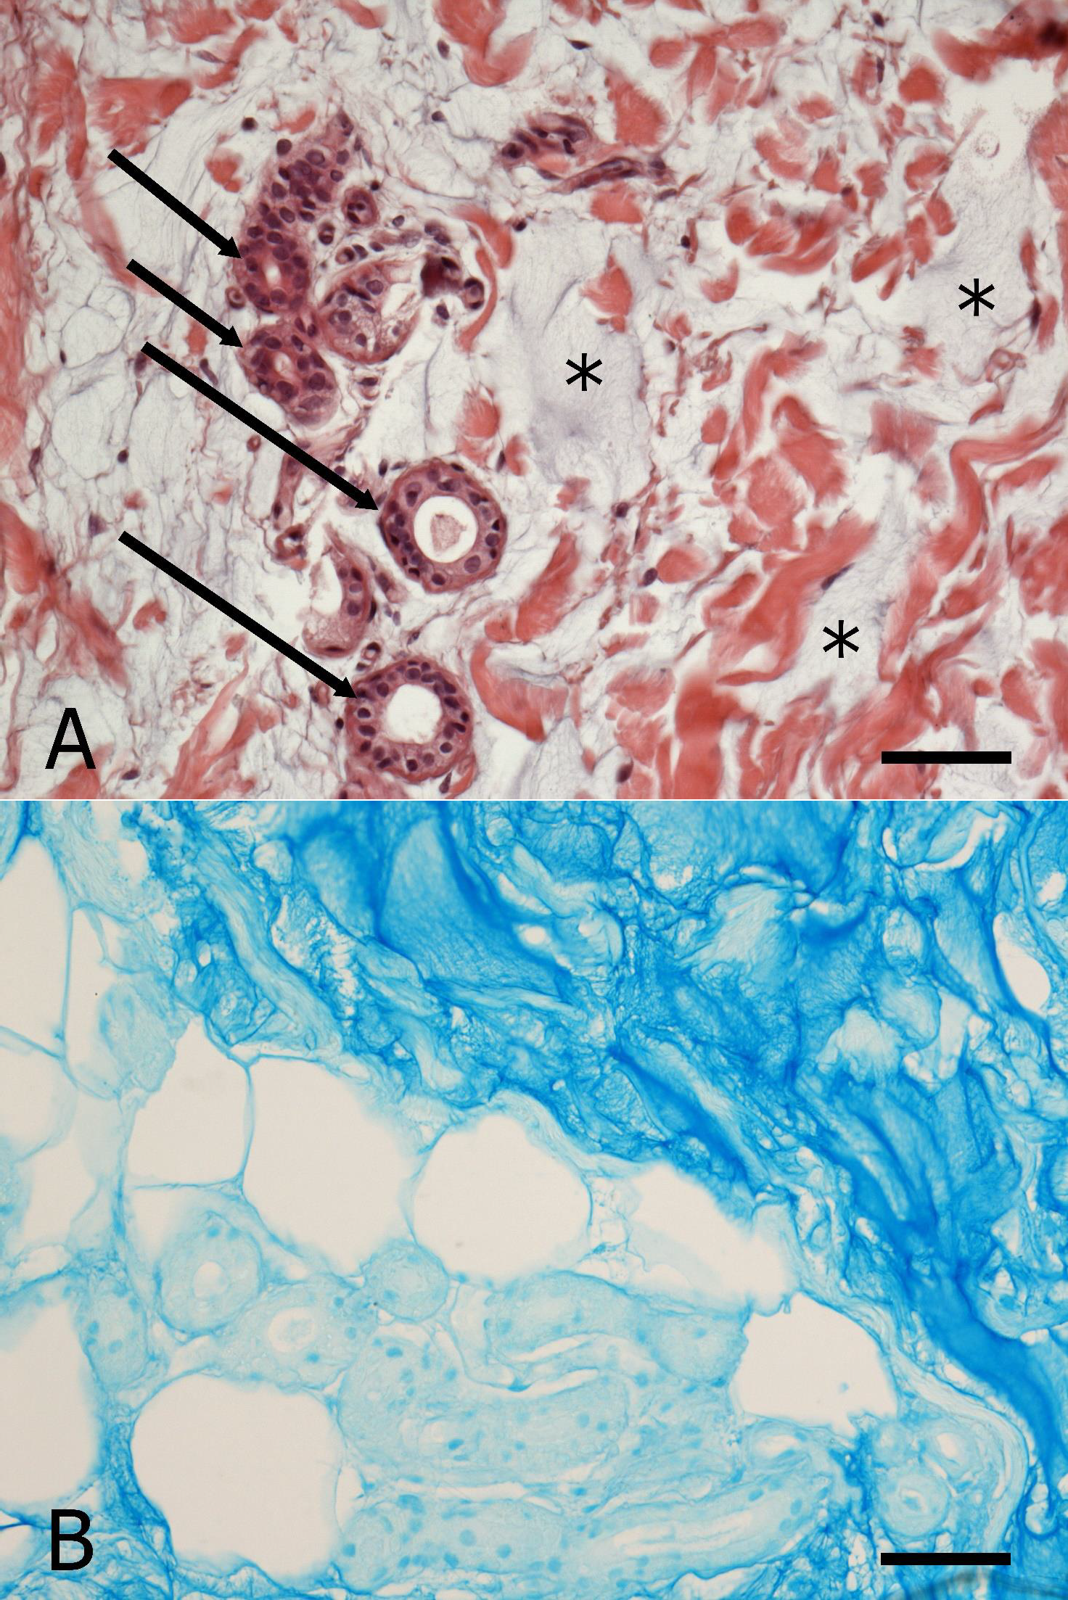
Accepted Article

Figure 5: A and B. Hipodermis sections stained respectively A) with Hematoxylin and Eosin, B) with Alcian Blue. A) The filler appears faintly blue stained (asterisks) in the interstitial ground matrix, between collagen fibres (red), some excretory tubules of sweat glands transversaly sectioned (arrows), single adipocytes and vessels. Fainty blue areas appear closely associated and integrated, without any encapsulation or discontinuity, with the cited structures.
Figure 5 B) In the right high part of the micrograph, the intensely blue stained area is representing the injected filler finely intermingled with thin collagen fibres, appearing as white areas because collagen is not stained by the Alcian blue. In the left low part of the image, some adipocytes (white and rounded) appear surrounding a phantom of some profiles of excretory ducts of glands variously oriented, finely surrounded by the dye but not specifically stained. Bar: 50 μm.
Accepted Article

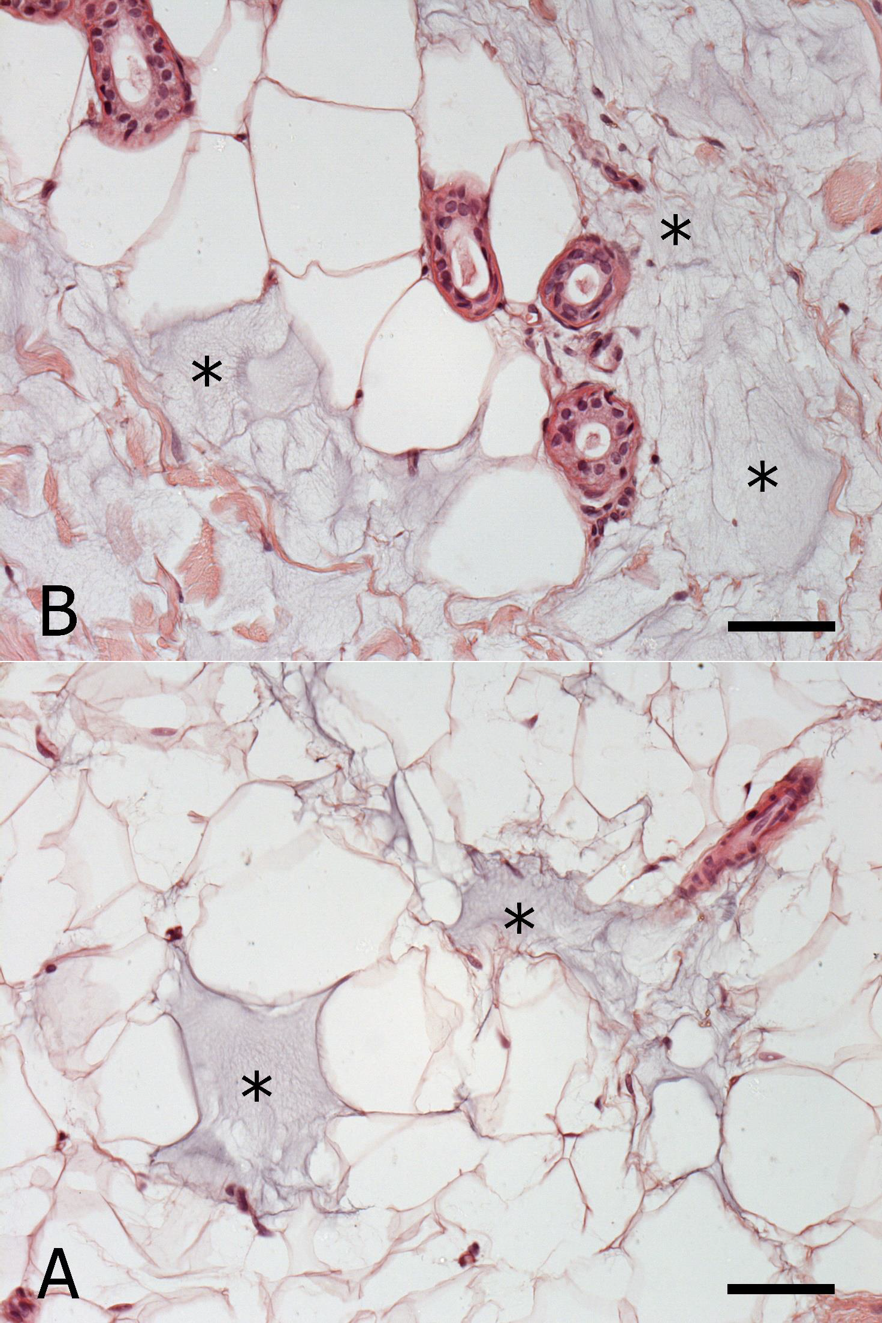
Accepted Article

Figure 6. In A) and B) stained with Hematoxylin and Eosin, the very close association between the filler, Alcian blue faintly stained (asterisks), and both adipocytes and excretory ducts of glands, is clearly appreciable as complete integration of the filler with the whole of tissue structures. Aspects of
Immunological reactions and/or related cells have never been detectable. Bar: 50 μm
Accepted Article

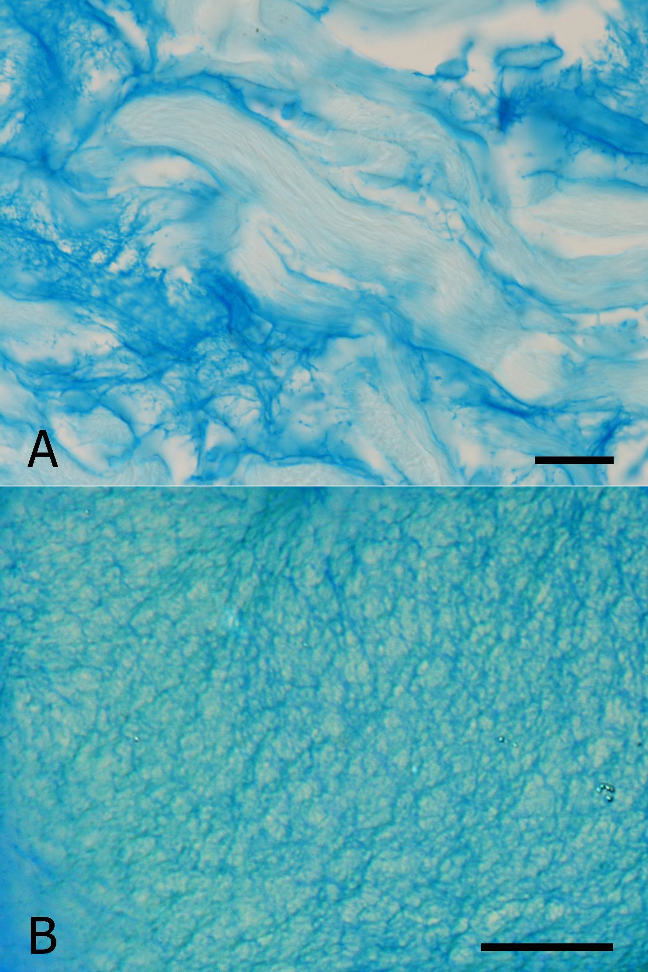
Accepted Article

Figure 7: High magnification. A) Blue stained areas, appear some compacted, others more dispersed, with fine branches variously oriented. At the center of the image, a collagen fiber (white) appears not stained by Alcian blue, as many other collagen profiles transversaly or obliquously sectioned.
B) Very high magnification, at the interferential light microscope, of a compacted filler area, appearing as a fine network constituted by extremely fine elements Alcian blue stained. The image is suggesting the tridimensional structural organization of the PEGylated hyaluronic acid constituting the filler, as
representation of the extremely extended surface of hydrophilic molecular sites of the filler. Bar: 10 μm.
Accepted Article

